Practical-4

Name : Jadhav Harshvardhan Vijaysinh

Reg. No. : 2020BIT065.

1. Travelling Salesman Problem.

Code :

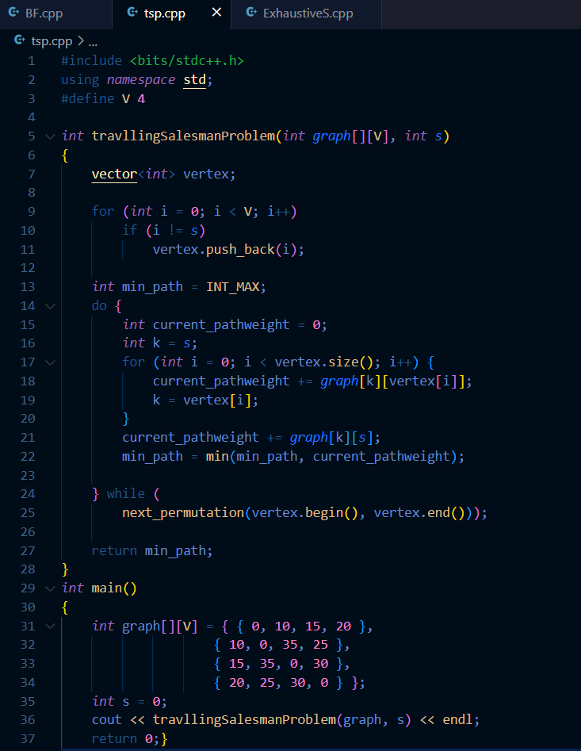

Output :

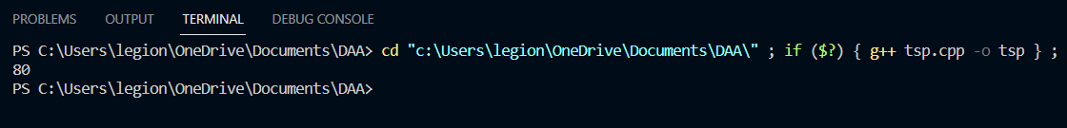

2. BF String Matching Algorithm.

Code :

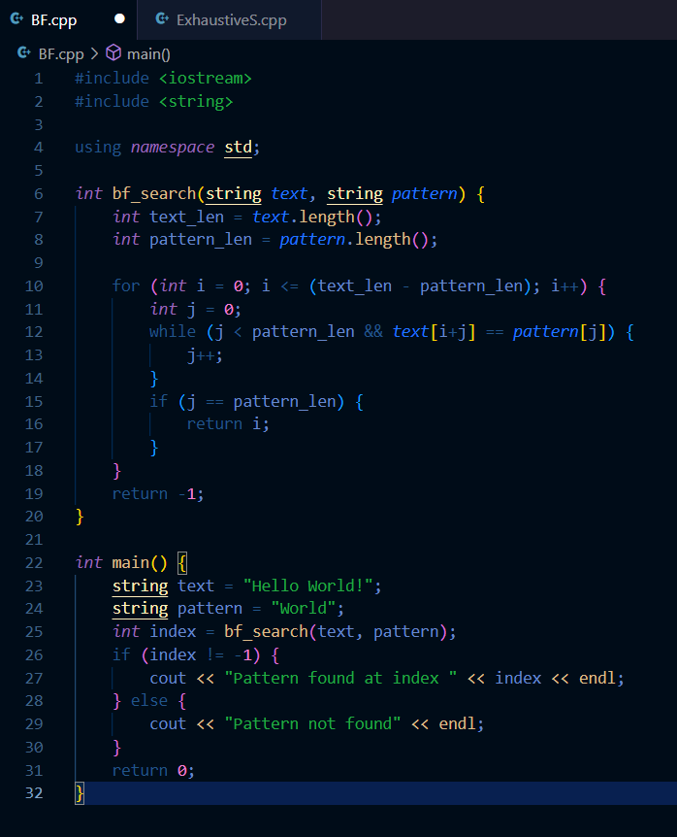

Output :

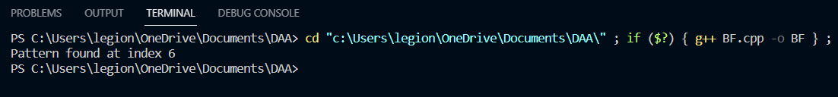

3. Exhaustive Search Algorithm.

Code :

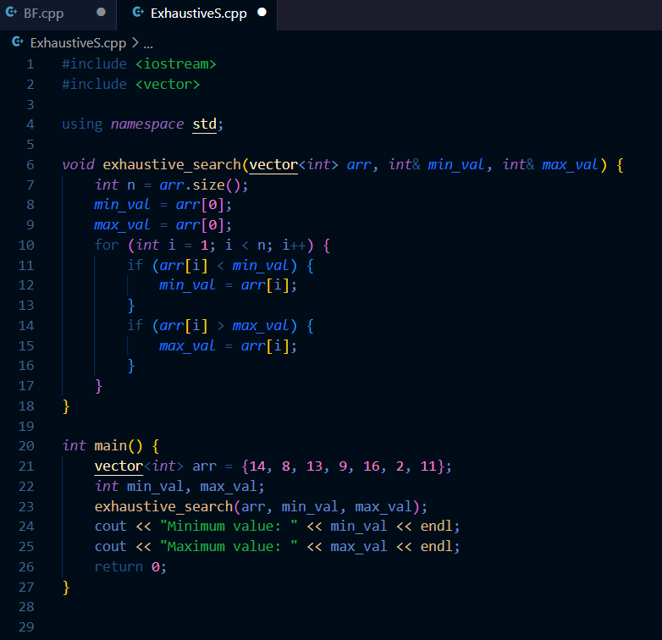

Output :

